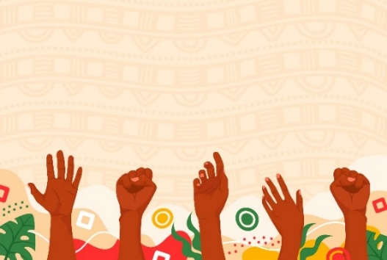
IDC Reflection Sheet –
Aboriginal and Torres Strait Islander Peoples
Reflecting on inclusive and intersectional practice
This sheet helps you reflect on how to build culturally safe and respectful relationships with Aboriginal and Torres Strait Islander or First Nations participants.
Inclusive practice means understanding the ongoing impacts of colonisation, recognising connection to Country, culture, and community, and supporting participants to ensure self-determination guides all engagement and decision-making.
A trauma informed approach is a framework that recognises the widespread impact of trauma and integrates healthy practices into all aspects of service delivery to promote safety, empowerment and resilience. It shifts the focus from asking, “What’s wrong with you?” to “What happened to you?” and emphasises understanding the effects of trauma on an individual’s emotions, behaviours, and overall functioning.
Thinking About Your Work
- Have you reflected on your own cultural background and how it shapes your work with Aboriginal and Torres Strait Islander participants?
- Do you take time learn about the Country you work on and acknowledge it meaningfully?
- How can you ensure that your engagement is guided by listening, learning, and humility?
- Consider your own power, privilege, and bias in your everyday practice.
How may the above considerations affect your interactions with the participant?
What strategies do you have in place to separate your personal life from your professional life to deliver the best quality of service?
Respecting Culture and Self-determination
- Do you recognise that Aboriginal and Torres Strait Islander participants are diverse, with many nations, languages, and cultures?
- How can you involve local community members, Elders or Aboriginal-controlled organisations’ in planning and decision-making?
- Think about the way you support participants — do you ask how you can best help them achieve their goals, and ensure their choices remain at the centre of your approach?
- How do you acknowledge and celebrate cultural strengths and resilience?

Cultural Safety and Accountability
- What does cultural safety mean in your role, and how do you demonstrate it?
- Do you challenge stereotypes and bias when you hear them?
- Does your organisation provide ongoing cultural awareness or safety training for staff?
- How can your workplace build deeper relationships with local Aboriginal and Torres Strait Islander communities?
Aboriginal and Torres Strait Islander peoples hold deep knowledge and strength- we practise inclusion when we listen and follow their lead.

Reflecting on Practice and Improvement
- How do you invite feedback from participants about their experience with your service?
- Do you act on feedback and let participants know their voices matter?
- How do you challenge bias, stereotypes, or discrimination when you see or hear them?
- What is one change you could make to improve your practice?

About This Resource
This reflection sheet was developed through co-design with people with lived experiences of disability, age, gender, culture including CaLD and First Nations, and intersectionality. It is intended as a general guide to support respectful and inclusive engagement with people from diverse backgrounds. It does not replace professional advice, cultural consultation, or relevant legal obligations. We encourage you to seek additional perspectives and resources to meet the unique needs of your participants and community.
© Inclusive and Diverse Communities Incorporated (IDC)

Resources and Further Reading
1. Trauma-Informed Services and Trauma-Specific Care for Indigenous Australian Children (AIHW)
2. Culture and Empowering Communities (National Indigenous Australians Agency)

